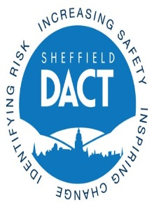

# **2017 Sheffield Recovery Awards**

## Do you know someone who? …

* **Runs a recovery focused group, activity or project that you think has made a difference in Sheffield?**
* **Is part of a family support/carer group or a family and carer volunteer/ family member that has made a difference in Sheffield?**
* **Has made outstanding progress and self-improvement, who deserves recognition?**
* **Someone who has made a real difference by volunteering their time to recovery in Sheffield?**
* **Has been working with a client that you think deserves recognition? They may have overcome many obstacles during their recovery?**

**If you answered YES to any of the above Questions please take the time to nominate this individual or group for Sheffield’s first Recovery Awards. There are 5 categories :**

* **The service user recovery initiative award**
* **The family & carer recovery initiative award**
* **Learner of the year award**
* **Volunteer of the year award**
* **Worker’s choice award**

**All applicants and nominees will be invited to attend an awards ceremony on Friday 29th September 2017**

**Application forms are available from:**

**Ask a member of staff**

**Download from** [**www.sheffielddact.org.uk**](http://www.sheffielddact.org.uk)

**Email** [**DACT@sheffield.gov.uk**](mailto:DACT@sheffield.gov.uk) **or** [**Tracey.ford@sheffield.gov.uk**](mailto:Tracey.ford@sheffield.gov.uk)

**Returning applications**

All completed nomination forms can be either posted to C/O, Sheffield Drugs and Alcohol | Domestic Abuse Co-ordination Team, Floor 9, East Wing, Moorfoot Building, Sheffield, S1 4UP

**OR**

Hand your completed application form to a member of staff

**OR**

Emailed to DACT@sheffield.gov.uk the DEADLINE for applications is **Monday 18th September**  NOTE any applications received after this date will not be put forward for judging