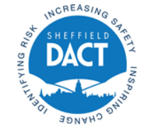
SPICE - UPDATED PROFESSIONAL INFORMATION BRIEFING

Our aim is for professionals who work with spice users throughout Sheffield to understand the citywide approach introduced in 2018. This will ensure professionals give a consistent approach. To do this we want professionals to:-
- Understand that COVID has not impacted on the treatment available for spice users;
- Feel equipped to work with spice users;
- Access the online training session to consolidate learning or access for the first time.

Support and treatment for spice users is available
Sheffield Health and Social Care have experienced recovery workers who provide the latest harm reduction advice, assess and refer spice users onto longer term treatment interventions when required.

Service users can walk in to Sidney Street during opening hours and receive immediate support.

The spice clinic, at Sidney Street is open for anyone to walk into on a Thursday afternoon 1pm to 3pm.

Recovery workers continue to provide street outreach in key locations, working with South Yorkshire Police and other agencies. Planned and responsive outreach to undertaken to meet need.

Professional information and guidance on how to work with spice users
The spice materials were developed in 2018 by Sheffield City Council’s Drug and Alcohol Coordination Team who worked in partnership with South Yorkshire Police, Yorkshire Ambulance Service, experts in the field and treatment providers. These have all been refreshed in 2020.

The 2 page response guidance leaflet (see the last two pages of this document) explains how to report to the police, when to phone an ambulance, the treatment service contacts details and has the 10 harm reductions messages.

Compete the online professional training course
The online training course is a recording of a live training session from 2018. The full session takes about 1 hour 20 minutes, however you can segment this into smaller chucks or focus on a specific area e.g. the emergency response. The training is useful for professionals who are new to Sheffield, those who have recently started working with spice users or if you want to refresh / consolidate learning from 2018.

If you want to complete the training email DACT@sheffield.gov.uk with your name, contact details and who you work for. We will respond with a link to the training and a guide on how to access the training.

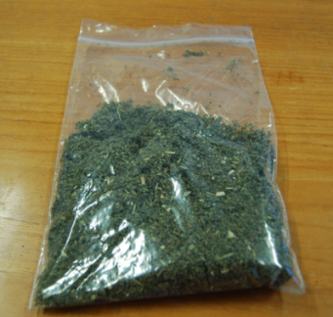
What is Spice?
Spice is the nickname used in Sheffield for an herbal substance which has been coated in a synthetic cannabinoid receptor agonist (or SCRA for short). Spice is the most used nickname for the drug however in some cities is has the nickname ‘black mamba’ (e.g. Birmingham). Spice is sold in small bags; it looks like a small bag of mixed herbs and is usually mixed with tobacco and smoked in a roll up.

Is Spice illegal?
Yes. The Psychoactive Substances Act 2016 made spice illegal to sell, manufacture, import and export. All Synthetic Cannabinoids most commonly found in Spice Class ‘B’ substances became illegal to possess following changes to the Misuse of Drugs Act 1971 in December 2016.

Is all Spice the same?
No. If you look at a bag of Spice, you may think they are all the same however there are over 200 types. Any slight change in the chemical make up creates a new SCRA.

New SCRAs are being developed all the time. This means batches of Spice can differ week by week and month by month. They can also have different levels of potency and therefore can make a difference in the severity of the side effects.

How is Spice made?
SCRAs are usually created abroad before being purchased on the internet in the UK. A SCRA is then usually mixed with liquid acetone e.g. nail varnish and then sprayed over an herbal plant such as thyme leaves to coat the leaves in SCRA. The mixing process may not be very effective so some leaves get coats more than others. Therefore a 1-gram bag may have a little SCRA on it and a second bag from the same batch a lot.

How strong is spice?
The strength of Spice can vary for several reasons including:-
- the chemical structure of the SCRAs;
- the number of SCRAs contained in the liquid drug;
- the quantity of SCRA compared to the amount of acetone content;
- how well the mixing process was completed.
All these factors impact on the drug’s potency and the side effects.

Why do people use Spice?
Spice is cheap to buy compared to other illicit drugs like heroin and gives a significant ‘hit’. It is also difficult to detect. It looks like people are smoking tobacco, it does not show on drug tests (unlike opiates) and some say it has no smell (although some workers say it smells fishy; which is the acetone that smells as it is smoked). All these factors can make it appealing for the most vulnerable in society; current drug users, the homeless, individuals with accommodation issues and prisoners.

How much does it cost to buy?
In Sheffield the price of Spice is not dissimilar to the areas of the country - it is relatively cheap buy. The price of Spice varies quite a lot but people are often buying ¼ of an ounce at a time (7 grams) and paying £20-£25 for it. This is around £40-£45 for a half ounce which is then often ‘shared’ between peers.

Why are the effects of Spice so strong?
SCRAs are strong, much more so than cannabis. Spice was first manufactured around 2008 and at this time it was around 8 times stronger than cannabis. The next version called the 2nd generation of Spice was around 100 times stronger than cannabis and the 3rd generation is up to 800 times more potent. Some people are now talking about a 4th generation; however intelligence on this is limited.

Tolerance
The body rapidly builds up tolerance to an SCRA, people can go from trying it out to feeling completely physically dependent in a very short period (e.g. days). This means users increase the amount of Spice they are using rapidly. Those who are addicted almost chain smoke it, often using within 15-20 minutes of the immediate side effects wearing off. The side effects are so severe those who are highly dependent even wake in the night to use.

More science…understanding tolerance – The body’s tolerance increases to each individuals chemical form of SCRA. Therefore if a different batch of spice contains a different chemical form, then there is no ‘cross-tolerance’ meaning that the hit is different and the body builds up a new tolerance to this new chemical SCRA. For users this is seen as a ‘good thing’, as chasing the first ‘hit’ in drug use is often heard about and this is the experience with Spice, with each new chemical form of SCRA providing the a new hit.

What does it do to the body? Warning…more science bit
Spice is often compared to cannabis because both substances contain cannabinoids which affect the same two types of receptors – CB1 and CB2 found in the body. CB1 receptors are mainly found in the brain and CB2 receptors are mainly found in the immune system which is located all around the body.

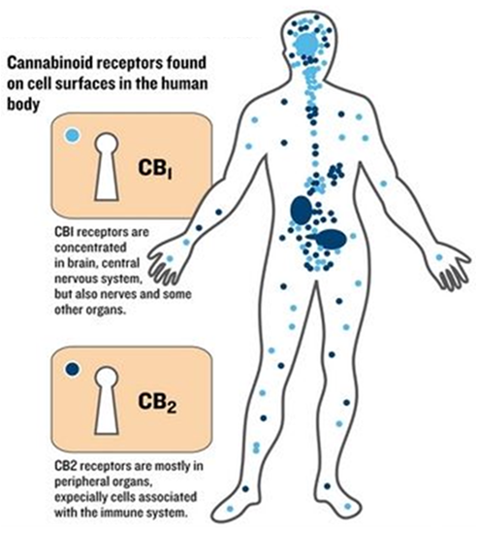

The difference between cannabis and SCRAs is that cannabis contains natural cannabinoids, including THC whilst Spice contains manufactured cannabinoids. This means they impact on the same CB1 and CB2 receptors in a different way. For example, when cannabis is smoked the THC content is released into the body and partially clings (a partial agonist) to the CB1 and CB2 receptors. SCRAs however are known as fully agonists and totally cling to the CB1 and CB2 receptors, meaning that Spice has a greater and stronger impact on the body.

SCRAs affect both the brain and the physical body – for example think of the most often used phrase for Spice users: the term ‘zombie’. In this state users are both physically unable to function and unable to communicate.

Spice users experience a variety of side effects – the full effects are experienced quickly after using, often within seconds, and then decline after around 30 minutes after use, although some SCRAs can remain in the body for a few hours.

The mental effects of spice
Spice users can experience a range of symptoms including frightening visions or hallucinations, becoming anxious, irritable and have psychosis-like effects, having inappropriate or uncontrolled laughter, feeling anger, sadness, and experience depression, panic attacks and have suicidal thoughts.

…and why users become aggressive…
Spice users can become agitated, feel combativeness, be aggressive, become paranoid, and have delusions, experience changes in perception and experience acute psychosis.

Short-term memory and cognitive deficits can be affected – users can become confused, look sedated, block their thoughts, experience nonsensical speech and amnesia - this is seen as one of the benefits for users who want to forget the ‘now’ and block out memories, current life experiences and difficulties.

The physical effects of spice
Spice users may experience a range of physical symptoms. Symptoms are influenced by the strength and potency of the SCRA, the tolerance the individuals has to the SCRA, other drugs and substances they have also used and/or medication they are using, their own health issues, and the time duration since they last used spice.

Spice users may experience the following symptoms after using spice
- a tight chest,  - a racing & irregular pulse,  - have breathing difficulties,  - headaches,  - collapse,  - have dizziness,  - numbness  - vomit  - Seizures,  - cardiac toxicity,  - sympathomimetic toxidrome (poisoning), | - chest pain,  - heart attack,  - renal injury,  - hypertension,  - unconsciousness,  - skin rashes,  - bleeding from the eyes and other orifices,  - teeth falling out,  - weight loss & loss of appetite,  - amnesia | 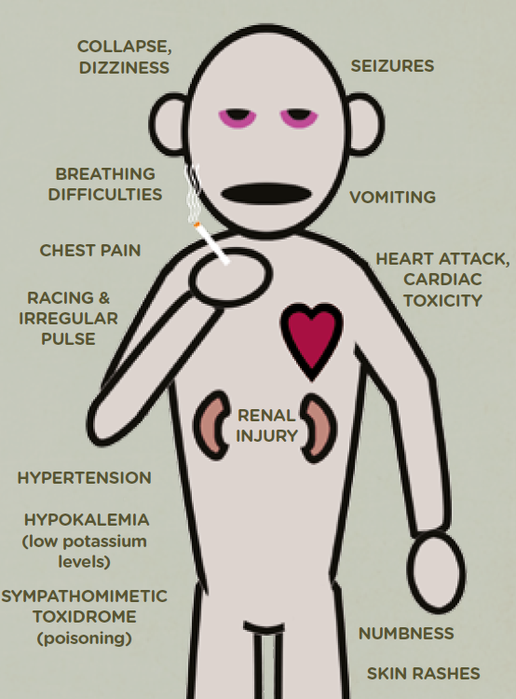

Contact with the ambulance service
Knowing when and how to contact the ambulance service is important when working with spice users. See the 2 page step by step worker guide on what to do with each symptom presented.

A key message from the ambulance service is to never place the spice user on their back, but always to place in the recovery position.

You should only put the person on their back when the ambulance service tells you to do so on a 999 call. This is on their instruction and so you can start performing lifesaving CPR. At all other times the recovery position should be used.

Can people die from using Spice?
Yes. In a minority of cases, Spice use can result in death and this has happened in Sheffield to a small number of individuals. The number of deaths associated to synthetic cannabinoids use has increased nationally, for example in 2018 the Office of National Statistics recorded 60 synthetic cannabinoids drug related deaths which was more than double than the 24 recorded in 2017.

What symptoms do people have who are addicted?
A survey with Spice users in Sheffield observed that frequent users of Spice (daily users) reported having experienced all side effects, had problems sleeping and could not stop using Spice.

Do Spice users use other drugs and what is the impact?
Our survey found over two thirds of Spice users were using other drugs as well and over 20% used with other drugs and alcohol. Spice users who use other illegal and prescribed medication are likely to have more problematic and more complex side effects.

Yorkshire Ambulance Service (YAS) have explained that any side effects experienced and observed should not be assumed to be due to Spice use, indeed other health conditions and other drugs (illicit and / or prescribed) also need to be factored in and may be unknown to the observer.

Can people be treated for their Spice use?
Yes, the drug treatment services in Sheffield provide a range of treatments for Spice users. Whilst there is currently no substitute medication regime other treatments are available. This includes harm reduction and health advice, comprehensive assessment, brief interventions, psycho social interventions and some pharmacological interventions. Treatment is provided to individuals aged 18 and over by Sheffield Health and Social Care Foundation Trust.

A weekly spice clinic is held however access to treatment is not limited to the clinic. Indeed Spice users can walk in to the treatment services during their opening hours and get professional advice. Drug workers also provide street outreach direct to service users. This often takes place with partners in South Yorkshire Police and street homeless services.

Does Spice treatment work?
There is limited academic and clinical research completed into this area, however we know that some Sheffield users of Spice have stopped using spice following support from the treatment services.

Do harm reduction message work?
Yes, we know of a number of users who have reduced their Spice use following brief interventions and harm reduction advice. Our survey found that the same harm reduction message can be delivered to different users and some will listen and others will not. This doesn’t mean we shouldn’t deliver harm reduction messages, it just may just mean the user needs to be in the right contemplation stage in the Cycle of Change to be ready to listen and act on the messages. For individuals in the pre-contemplation stage professionals should deliver harm reduction messages at every opportunity and when users are ready to listen and act, they are informed.

THE CITYWIDE RESPONSE TO SPICE – SEE LAST TWO PAGES
This contains the key messages all professionals should know and use when working with spice users.

THE SHEFFIELD CITYWIDE RESPONSE TO SPICE
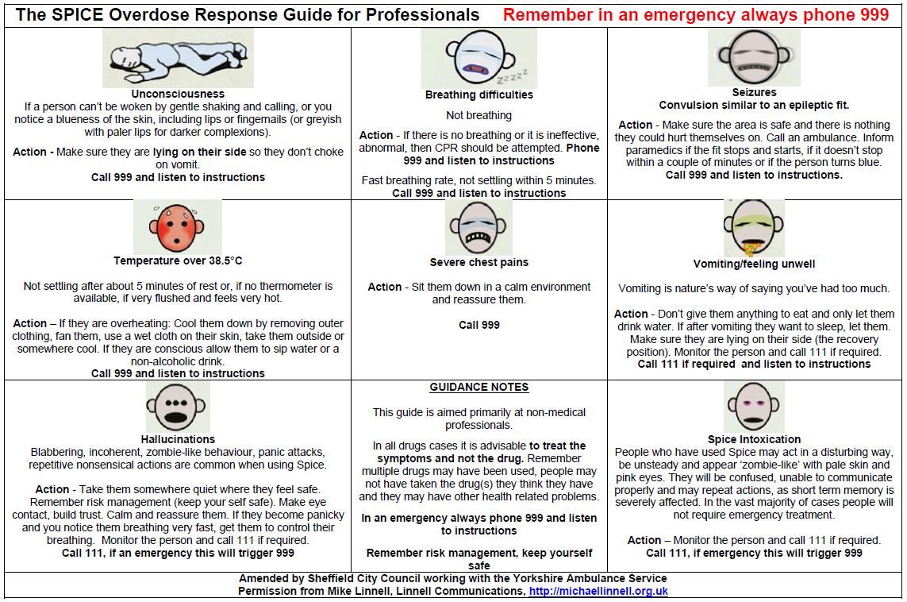
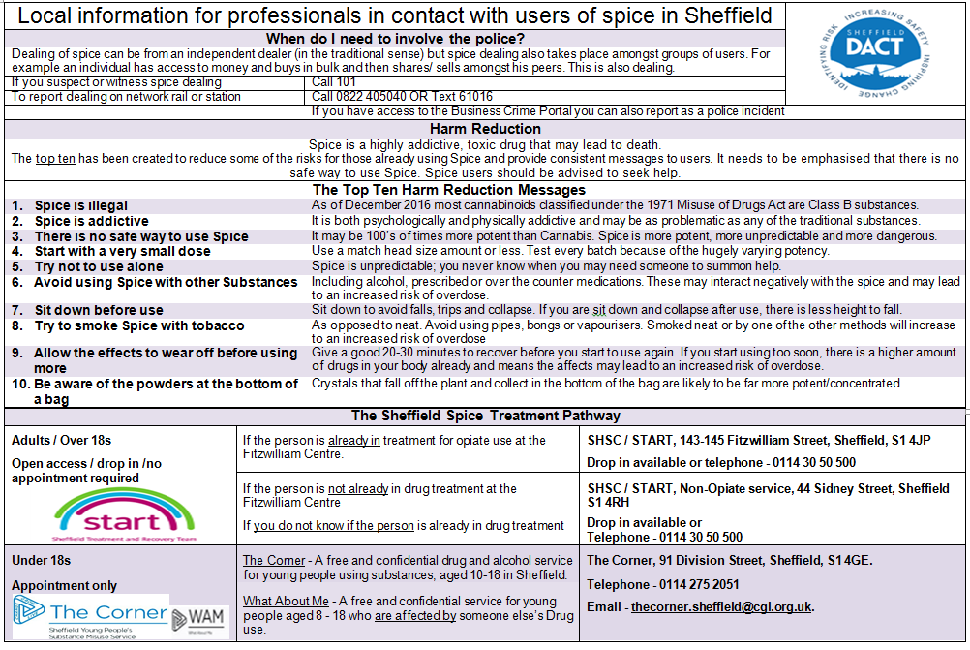

https://sheffielddact.org.uk/drugs-alcohol/wp-content/uploads/sites/2/2020/08/SPICE-Sheffield-leaflet-Aug-2020.pdf
https://www.ons.gov.uk/peoplepopulationandcommunity/birthsdeathsandmarriages/deaths/datasets/deathsrelatedtodrugpoisoningbyselectedsubstances

